SWAMI DHANANJOY DAS KATHIABABA MAHAVIDYALAYA

BHARA, BANKURA
STATE AIDED COLLEGE UNDER BANKURA UNIVERSITY
NAAC ACCREDITED (GRADE – B)

COLLEGE WEBSITE : https://www.sddkm.in

PROSPECTUS : 2025-2026

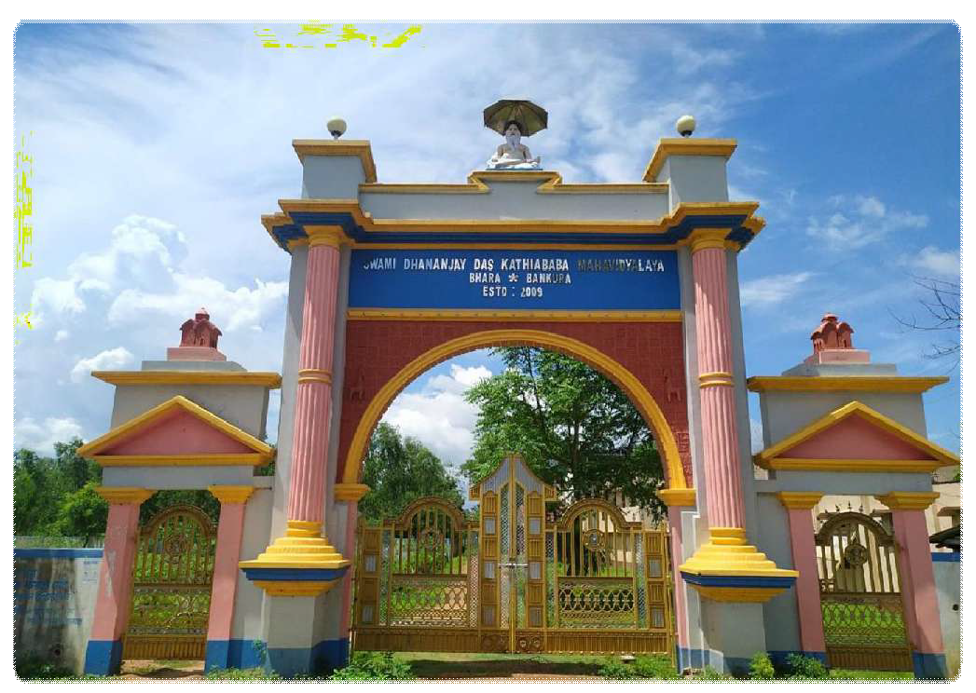

WELCOME NOTE FROM PRINCIPAL’S DESK
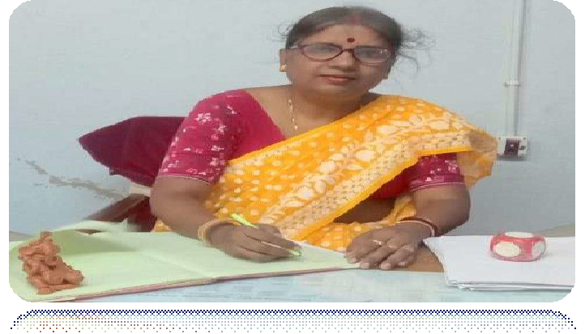
As the Principal of this esteemed institution, it gives me immense pleasure to introduce our college to all prospective applicants. The onset of the 2025-26 academic session National Education Policy will be running with full pomp and grandeur. As we witness such momentous changes in the education sector, carrying out the task of disseminating knowledge and enriching young minds brings with it fresh challenges. We have already witnessed unprecedented changes in the curriculum with the introduction of blended learning and online classes during the Covid-19 pandemic. Although young in terms of years Swami Dhananjoy Das Kathiababa Mahavidyalaya has risen to meet the challenges that the pandemic has created for the education sector, doing the needful to upgrade its digital infrastructure in order to facilitate student-teacher interaction and provide an extended platform for interaction beyond the class room.
We are one of the few colleges in the Bankura district which has successfully implemented the Enterprise Resource Planning Software (ERP), to facilitate distribution of study materials and conduct remote teaching as part of a well-planned curriculum, recreating classroom discipline within a virtual space. While we prioritize in-person interactive classes, the revolutionary implications of digital technology in reshaping the curriculum and teaching methodologies cannot be ignored. In future we hope to supplement offline classroom teaching with digital technology which can act as an extension of traditional pedagogical tools used in conventional teaching. The Enterprise Resource Planning Software developed for this purpose will remain functional to enable students to access lecture presentations and submit assignments beyond college hours. I would encourage all newly admitted students to familiarize themselves with the ERP software to make the most of online resources that the college has to offer.
Located in the heart of the village of Bhara, the college is the cynosure of all eyes. The village is the birthplace of a holy Hindu saint, Swami Dhananjoy Das Kathiababa Maharaj, who is the founding Father of the college. The infrastructure that the college has is second to none. We have a dedicated faculty who teach our students with utmost care to be self-reliant and pragmatic such that when they enter life after their studies, they can face various challenges with courage and conviction. I am sure our students will always strive to uphold the dignity four college and keep its flag flying high.
There is a genuine sense of community amongst teachers, students, parents and staff members, which we are all very proud of. I wish the best of fortune, peace and prosperity to all those who participate in then able task of spreading education and improving minds. I would like to conclude by extending my heartiest congratulations to outstanding and meritorious students who have excelled in university exams. In this context I would especially like to bring to your attention the commendable achievement of our ex-student Samapti Acharya from the department of History Honours, who topped the University exams in 2021 and wasfelicitatedastheGoldMedalist.Iwishourstudentstheverybestandwishthemallsuccessintheirendeavors.

Best wishes,
DR KAKALI GHOSH SENGUPTA

BRIEF HISTORY:
Swami Dhananjoy Das Kathiababa Mahavidyalaya was established in 2009 with the objective of making higher studies accessible to the underprivileged sections of society. The college has played a seminal role in encouraging the youth of Bhara and its adjoining villages to enroll for higher studies. Located in the remote village of Bhara, roughly about 20 kilometers from the tourist town of Bishnupur, in the district of Bankura, the college is an outcome of the earnest endeavor of the local administration and eminent members of the village community. Named after the 56th Acharya of the Akhil Bharatiya Nimbarka religious sect, the institute has a pan-Indian association in terms of its affiliation with the Kathiababa trust and foundation. Disciples from both home and abroad tribute to its infrastructural development and academic enrichment.
Classes were initially conducted in the adjacent High School and the first batch of students added to a total of 71 in 2009. In the following year in 2010, classes formally began at the college premises. Since then, the infrastructure of the college has evolved and there has been a simultaneous increase in student strength. The alumnus of the college has been absorbed into various branches of higher education and they have exhibited a strong commitment towards career development and personal growth. Recently our college is accredited with Grade-B by NAAC Peer Team in September, 2024.
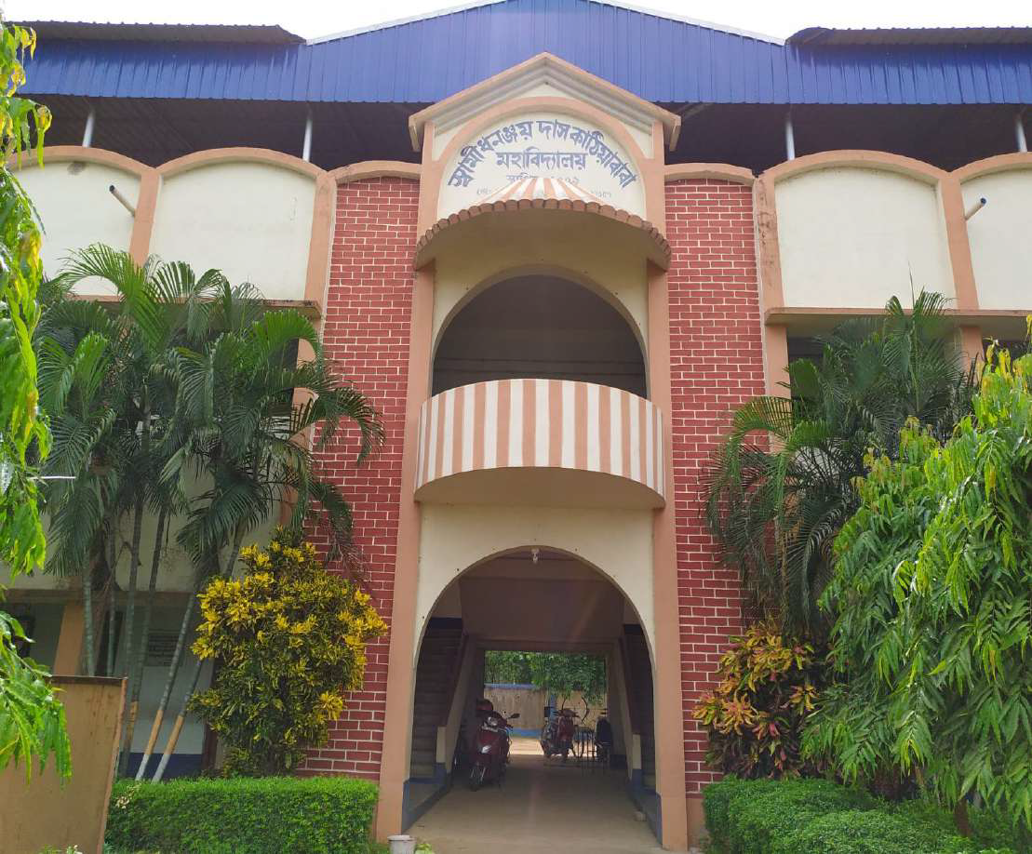

VISION AND MISSION:
VISION: Swami Dhananjoy Das Kathiababa Mahavidyalaya was established with a vision of inclusive education that would cater to the under privileged section. Since its inception in 2009, the institution has nurtured aspirations for higher education in the rural youth empowering the rural youth especially women from tribal communities by providing them with academic resources in the form of texts and audio-visual material to enhance their cognitive development. This has brought about a positive change in the rural community and strengthened the network of knowledge transmission resulting in greater assimilation in terms of employment opportunities. The simultaneous increase in the level of awareness has left a positive impact in the quality of intellectual life paving the way for innovative thinking. The college seeks to nurture e innovative thinking through an optimum utilization of its limited resources. The strength of the institution lies in its potential to cultivate its human resources and instill independent thinking in a liberal academic environment.

MISSION:

- To create an academic ambience that can instill a strong love for learning
- To develop a practical pedagogy and a holistic learning approach where students are able to link the knowledge acquired, with everyday practices.
- To ensure students get adequate exposure to national and state level academic programmes and services
- To enable educational professionals and faculty-members to reach global standards in terms of scholarship, research and training through participation in academic workshops and seminars.
- To ensure gender sensitization through the Women’s Cell
- To inculcate a positive sense of self-worth.
- To create an inter disciplinary platform for learning through regular seminars, workshops, talk sand film screenings.
- To instill a sense of social responsibility.
- To nurture a strong and diverse community of scholars
- To provide career-counseling and ensure assimilation in the work space through the Placement Cell.
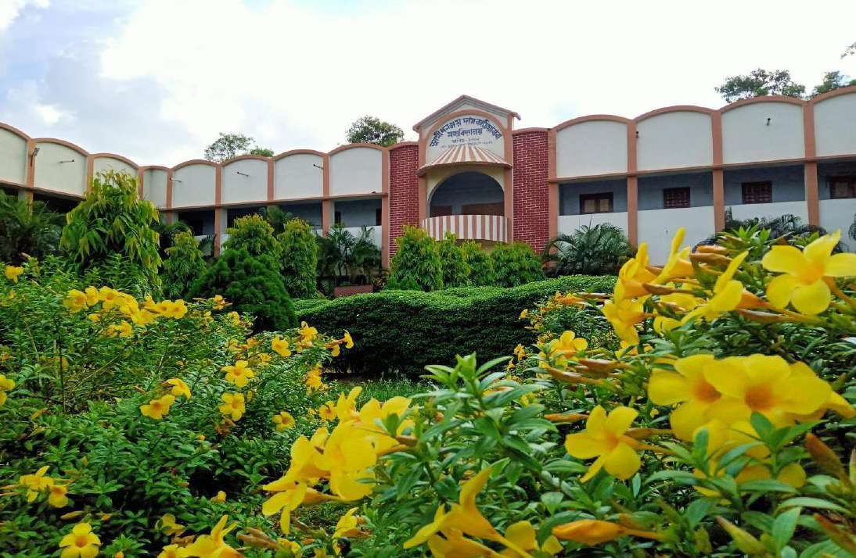

COLLEGE GARDEN IN FULL BLOOM

GOVERNING BODY MEMBERS
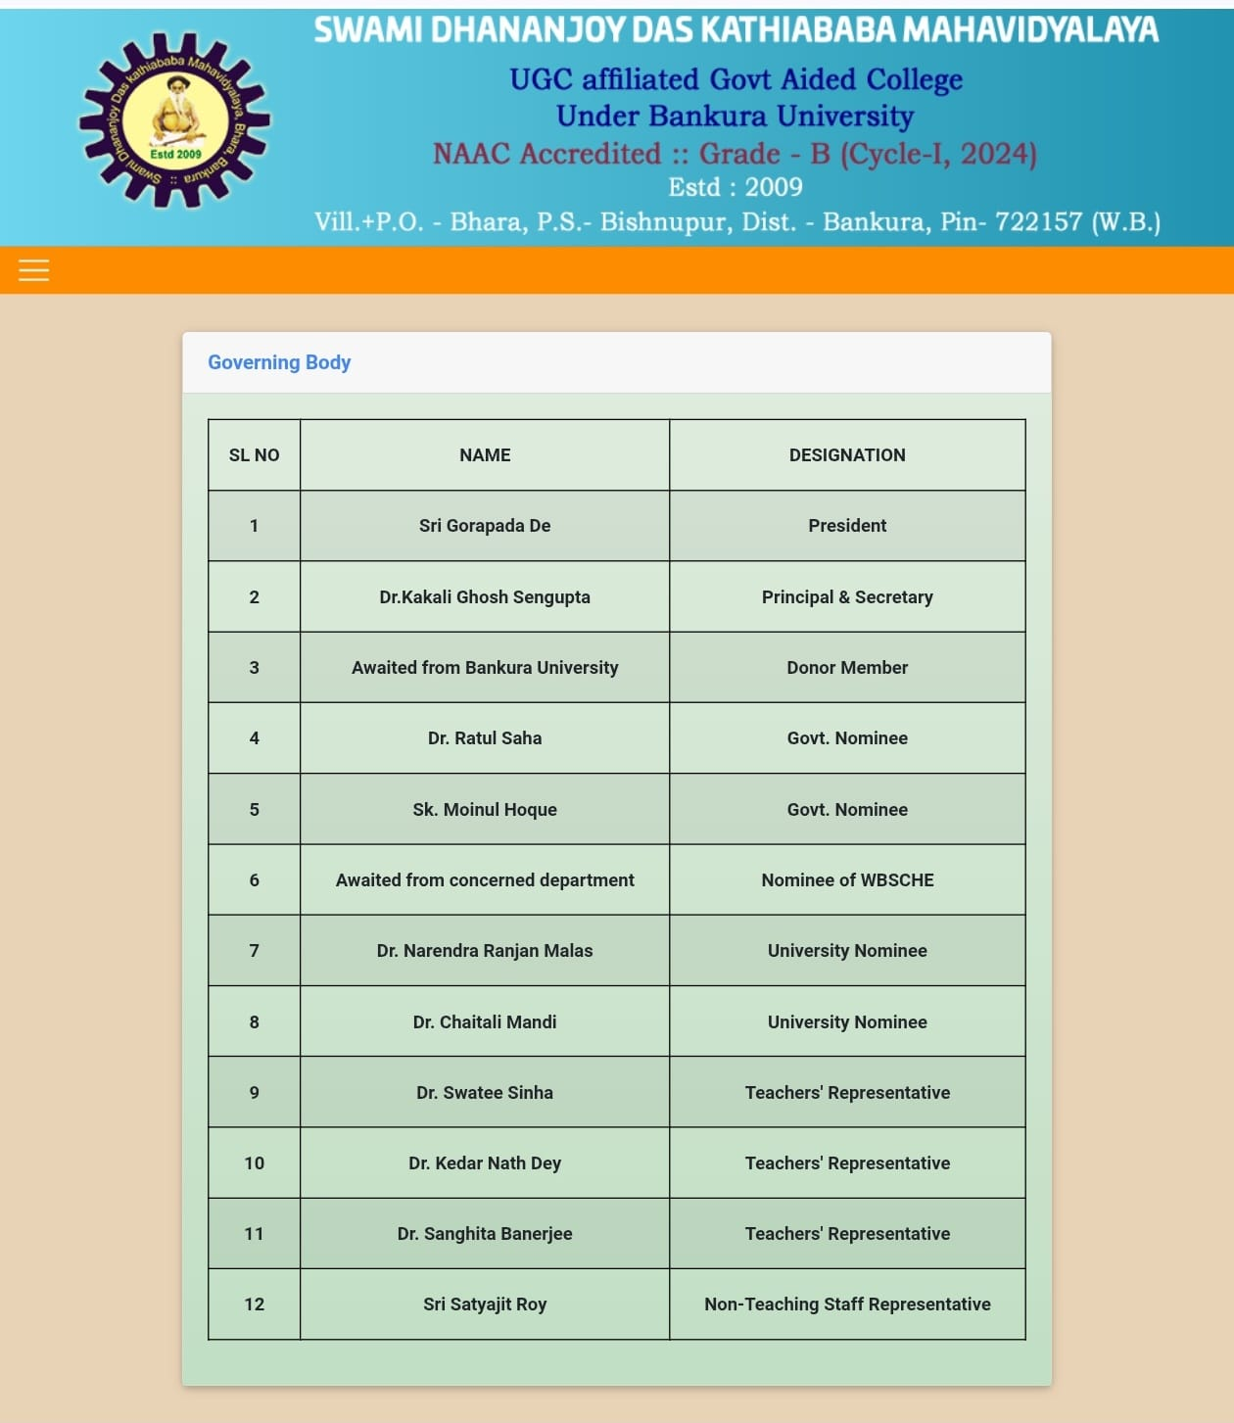

FACULTY MEMBERS
Serial No. | Name & Qualification | Designation | Subject being taught by him/her
 | Dr. Kakali Ghosh {Sengupta), M.A, M. Phil, Ph.D. | Principal & Secretary | Philosophy
 | Dr. Mahuya Bandyopadhyay, M.A., Ph.D. | Assistant Professor | Geography
 | Dr. Swatee Sinha, M.A., M. Phil. Ph. D. | Assistant Professor | English
 | Dr. Kedar Nath Dey, M.A., Ph. D. | Assistant Professor | Education
 | Bipul Chandra Manda/, M.A., M.Phil. | Assistant Professor | History
 | Dr. Rafia Sultana Molla, M.A., M. Phil. Ph. D | Assistant Professor | Bengali
 | Dr. Sanghita Banerjee, M.A. Ph. D. | Assistant Professor | Bengali
 | Doma Sherpa M.A. | Assistant Professor | Political Science
 | Atasi Sahoo M.A., M. Phil. | Assistant Professor | English
 | Payel Shee, MLISc., M. Phil | librarian
 | Soutick Bhattacharyya, M.A. | Govt Approved SACT-ll | English
 | Tanusri Roy, M.A. | Govt Approved SACT-Il | Political Science
 | Dr. Tanusree Dey, M.A., Ph.D. | Govt Approved SACT-I | Bengali
 | Joydeep Kr. Dey, M.A, M.Phil. | Govt Approved SACT-II | Bengali
 | Monalisa Laha, M.A, M.Phil. | Govt Approved SACT-II | Bengali
 | Kakali Brahma, M.A. | Govt Approved SACT-ll | History
 | Sandip Nandi M.A. | Govt. Approved SACT-II | Geography
 | Moyna Chatterjee, M.A. | Govt. Approved SACT-II | History
 | Shibdas Hembram, M.A. | Govt Approved SACT-Il | History
 | Apu Ghosh, M.A. | Govt. Approved SACT-II | Sanskrit
 | Subir Baj, M.A. | Govt Approved SACT-II | Sanskrit
 | Amit Samanta, M.A, M.P.Ed. | Govt Approved SACT-II | Physical Education
 | Saroj Marik, M.A., M.P.Ed. | Govt Approved SACT-II | Physical Education
 | Bharat Tudu, M.A. | Govt. Approved SACT-II | Santali
 | Anjali Kisku, M.A. | Govt Approved SACT-I | Santali
 | Iman Kalyan Malik, M.A. | Govt Approved SACT-II | Education
 | Chand Adhikary, M.A. | Govt Approved SACT-I | Pol. Science
 | Kuheli Dey, M.A. | Govt. Approved SACT-II | Philosophy
 | Pallabi Das, M.A., M.Phil. | Govt Approved SACT-ll | Sociology
 | Gita Murmu, M.A. | Govt. Approved SACT-I | Santali
 | Rajkumar Murmu, M.A., M.Phil. | Govt. Approved SACT-I | Santali
 | Shibnath Bid, M.A. | Govt Approved SACT-ll | Sociology
 | Satyajit Tudu, M.A. | Govt. Approved SACT-I | Santali
 | Anil Rana, M.A. | Govt. Approved SACT-II | Education

OFFICE STAFF
SI No. | Name & Qualification | Designation
1 | Satyajit Roy, M.Sc. | Accountant & Head Clerk (Addle. Charge)
2 | Tufan Sarkar, B.Com.(Hons.) | Cashier
3 | Surajit Monda/, B.Sc. | Clerk
4 | Sujit Mandal, B.Sc. | Typist
5 | Shyamsundar Mandal, M.P. | Peon
6 | Sukdeb Bagdi, M.P. | Peon
7 | Barun Mukherjee, M.P. | Guard
8 | Haru Bagdi, Vlll Std. | Part-Time Sweeper (Govt, Appd.)
9 | Anup Kr. Ghosh, B.A. | Office Peon (Casual)
10 | Sourav Dey, B.A. | Gymnasium instructor (Temporary)
11 | Ranjan Chakraborty, M.P. | Hostel Cook (Casual)
12 | Bablu Lahar, Vlll Std. | Hostel Helper (Casual)

ANTI-RAGGING CELL

What constitutes Ragging?
- Ragging constitutes one or more of any of the following acts: a. any conduct by any student or students whether by words spoken or written or by an act which has the effect of teasing, treating or handling with rudeness a fresher or any other student.
- indulging in rowdy or undisciplined activities by any student or students which causes or is likely to cause annoyance, hardship, physical or psychological harm or to raise fear or apprehension thereof in any fresher or any other student.
- asking any student to do any act which such student will not in the ordinary course do and which has the effect of causing or generating a sense of shame, or torment or embarrassment so as to adversely affect the physique or psyche of such fresher or any other student.
- any act by a senior student that prevents, disrupts, or disturbs the regular academic activity of any other student or a fresher.
- exploiting the services of a fresher or any other student for completing the academic tasks assigned to an individual or a group of students.
- any act of financial extortion or forceful expenditure burden put on a fresher or any other student by senior students.
- any act of physical abuse including all variants of it: sexual abuse, homosexual assaults, stripping, forcing obscene and lewd acts, gestures, causing bodily harm or any other danger to health or person;
- any act or abuse by spoken words, emails, post, public insults which would also include deriving perverted pleasure, vicarious or sadistic thrill from actively or passively participating in the discomfiture to fresher or any other student.
- any act that affects the mental health and self-confidence of a fresher or any other student with or without an intent to derive a sadistic pleasure or showing off power, authority, or superiority by a student over any fresher or any other student.
The Anti-Ragging Cell of the college under the guidance of Dr. Mahuya Bandyopadhyay is committed to curbing all acts of ragging on campus. The Anti Ragging committee will take strict disciplinary action against any student who indulges in any of the aforementioned acts which fall within the purview of ragging.



NATIONAL EDUCATIONAL POLICY (2020)

  - This policy envisions a complete overhaul and re-energizing of the higher education system to deliver high-quality higher education, with equity and inclusion.
  - The policy’s vision includes the following key changes to the current system:
    - moving towards a higher educational system consisting of large, multidisciplinary universities and colleges, with at least one in or near every district, and with more HEIs across India that offer medium of instruction or programmes in local/Indian languages;
    - Moving towards a more multidisciplinary undergraduate education;
    - Moving towards faculty and institutional autonomy;
    - Revamping curriculum, pedagogy, assessment, and student support for enhanced student experiences;
    - Reaffirming the integrity of faculty and institutional leadership positions through merit appointments and career progression based on teaching, research, and service;
    - Establishment of a National Research Foundation to fund outstanding peer-reviewed research and to actively encourage seed fund research in universities and colleges;
    - Governance of HEIs by high qualified independent boards having academic and administrative autonomy;
    - “light but tight” regulation by a single regulator for higher education;
    - increased access, equity, and inclusion through a range of measures, including greater opportunities for outstanding public education; scholarships by private/philanthropic universities for disadvantaged and underprivileged students; online education, and Open Distance Learning (ODL); and all infrastructure and learning materials accessible and available to learners with disabilities

STRUCTURE AND LENGTH OF DEGREE PROGRAMMES:
- The undergraduate degree will be of either 3 or 4-year duration, with multiple exit options within this period, with appropriate certifications, e.g., a certificate after completing 1 year in a discipline or field including vocational and professional areas, or a diploma after 2 years of study, or a Bachelor ’s degree after a 3-year programme.
- An Academic Bank of Credit (ABC) shall be established which would digitally store the academic credits earned from various recognized HEIs so that the degrees from an HEI can be awarded taking into account credits earned.
- HEIs will have the flexibility to offer different designs of Master’s programmes: (a) there may be a 2-year programme with the second year devoted entirely to research for those who have completed the 3-year Bachelor ’s programme; (b) for students completing a 4-year Bachelor ’s programme with Research, there could be a 1-year Master’s programme; and (c) there may be an integrated 5-year Bachelor’s/Master’s programme.
- Undertaking a Ph.D. shall require either a Master’s degree or a 4-year Bachelor’s degree with Research.
- The M.Phil. programme shall be discontinued.

Structure of UG Single Core Discipline Program

DSC: Discipline Specific Course DSE: Discipline Specific Electives GE: General Electives
AEC: Ability Enhancement Course
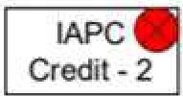

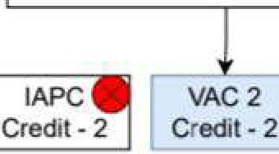
IL - Pool of Indian Languages in the 8th schedule of the Constitution
One from the Pool of GE Courses One from lhe Pool of SEC Courses
Total Sem Credits - 22
SEC2
Credil-2
GE2 AEC
Credit-4 Cl"edit-2
DSE
Credlt-4
Discipline Specific Course - 4, Credit - 4
Discipline Speclfic Course - 5, Credit- 4
Discipline Specific Course • 6, Credit - 4
One from the Pool of VAC Courses
I-L1/Environment Sc - 1
SEM -111-------------L --.
One from the Pool of SEC Courses
One from the Pool of GE Courses
Total Sem Credits. 22
VAC1
Credit- 2
SEC 1
Credit- 2
GE1 AEC
Credit-4 Credit· 2
DSE
Credit -4
Discipline Specific Course - 1, Credit - 4
Discipline Specific Coursre - 2, Credit - 4
Discipline Specific Coursre - 3, Credit - 4
One from the Pool of VAC Courses
IL - 1 / Environment Sc - 1
SEC: Skill Enhancement Course
IAPC: Internship/Apprenticeship/ Project Community Outreach
VAC: Value Addition Course
- : Not Applicable

First Year
SEM -1 1 -._

One of the Transformative Initiatives in Higher Education Undergraduate Degree Programmes of either 3 or 4-year duration, with multiple entry and exit points and re-entry options, with appropriate certifications such as:
  - a UG Certificate after completing I year (2 Semesters) of study in the chosen fields of study,
  - a UG Diplon1a aft r 2 years (4 Semesters) of study,
  - a Bachelor's Degree after a 3-year (6 Semesters) programme of study,
  - a Bachelor's Degree (Honours) after a 4-year (8 Semesters) programme of study. If the students complete a rigorous research project/ dissertation in their major area(s) of study in the 4th year of a bachelor's degree then (Honours with Research).
A semester comprises 90 working days and an academic year is divided into two semesters.
A summer term is for eight weeks during summer vacation. Internship/ apprenticeship/ work-based vocational education and training can be carried out during the su1TI.rn.er term, especially by students who wish to exit after two semesters or four semesters of study. Regular courses may also be offered during the summer on a fast-track mode to enable the students to do additional courses or complete backlogs in coursework. The HEIs can decide on the courses to be offered in the summer term depending on the availability of faculty and the number of students.
Broad Category of Courses
•Major/ DS Cours (Core)
  - Minor Course
  - Multidisciplinary Course
  - Ability Enhancement Course (AEC)
  - Skill Enhancement Course (SEC)
  - Value Added Course (VAC)
  - Internship
  - Research Project / Dissertation.
Table I: Minimum Credit Requirements to Award Degree under each Category •
(as per UGC guideline regarding CCFUP)
Sl. No. Broad Category of Course Minimum Credit Requirement
• | 3-year UG  1 Major (Core) 60 | 4-yearUG  80
 | 2 Minor Stream 24 | 32
 | 3 Multidisciplinary 09 | 09
 | 4 Ability Enhancement Courses (AEC) 08 | 08
• | 5 Skill Enhancement Course (SEC) 09 | 09
 | 6 Value Added Courses common for all UG 06-08 | 06-08
 | 7 Summer Internship 02-04 | 02-04
 | 8 Research Project/ Dissertation | 12

Total 120 160
Note:* Honours Student not undertaking research will do 3 course for 12
credit. in lieu of a research project/ Dissertation

- - - -
SEMESTER WISE & COURSE WISE CREDIT DISTRIBUTION STRUCTURE UNDER NEP, 2020 at UG LEVEL {HONOURS with RESEARCH)
Sem este r | MAJOR  (106 Credits) |  |  | MINOR  (32 Credits) |  |  | Multi/Interdisciplinary Courses  {9 Credits) |  |  | AEC {Languages 8 Cr.) [MIL(L1)= Arabic/ Beng. Hindi/ Sanskrit/ SantaIi/ Urdu) & English {LZ) |  |  | SEC (9 Credits) |  |  | skill based vocational Course (Addi. 4 Cr.)/ Internship  Cr, 21 |  |  | Research project/ Dissertation (12Cr.) |  |  | VAC (8Cr.)
Sem este r | No. of Cou rse( s) | Cr./ cour se | Cour se wise total Cr. | No. of Co urs e(s) | Cr./ cour se | Cour se wise total Cr. | No. of Co urs e(s) | Cr./ cours e | Course wise total Cr. | No.of Course(s) [MIL&  English] or Equvlnt. Course from SWAYAMor  Ugc  recognized others | Cr./ cours e | Cour se wise total Cr. | No. of Cour se | Cr./ cour se | Cour se wise total Cr. | No. of Cour se | Cr./ cours e | Cours e wise total Cr. | No. of Cour se | Cr./ cours e | Cours e wise total Cr. | No. of Cour se | Cr./ cour se | Cour se wise total Cr. | Sem. wise total  Cr. | Sem. wise no. of Cour  ses
I | 1 | 4 | 4 | 1 |  | 4 | 1 | 3 | 3 | 1 (L1•l MIL) | 2 | 2 | 1 | 3 | 3 |  |  |  |  |  |  | 1 | 4 | 4 | 20 | 6
II | 1 | 4 | 4 | 1 | 4 | 4 | 1 | 3 | 3 | 1 (lz-1 Eng.) | 2 | 2 | 1 | 3 | 3 | 1 | 4 | 4 | Skill based Vocational Course  {additional 4 Cr.) during summer term for the Students who will exit the programme after securing40  credits. |  |  | 1 | 4 | 4 | 20 | 6
Ill | 2 | 5 | 10 | 1 | 4 | 4 | 1 | 3 | 3 | 1 (L1·2 MIL) | 2 | 2 | 1 | 3 | 3 |  |  |  |  |  |  |  |  |  | 22 | 6
IV | 3 | 5 | 15 | 1 | 4 | 4 |  |  |  | 1 (lz-2 Eng.) | 2 | 2 |  |  |  | 1 | 4 | 4 | Skill based Vocational Course (additional 4 Cr.) during summer term for the Students who will exit the programme after securing83  credits. |  |  |  |  |  | 21 | 5

V | 3 | 5 | -  15 | 1 | 4 | -  4 |  |  |  |  |  |  |  |  |  | 1 | 2 | 2 | Internship for all . |  |  |  |  |  | 21 | 5
VI | 4 | 4 | 16 | 1 | 4 | 4 |  |  |  |  |  |  |  |  |  |  |  |  |  |  |  |  |  |  | 20 | 5
VII | 4 | 6 | 24 | 1 | 4 | 4 |  |  |  |  |  |  |  |  |  |  |  |  | Research Project/ Dissertation initiation |  |  |  |  |  | 28 | 5
VIII | 1 | 6 | 6 | 1 | 4 | 4 |  |  |  |  |  |  |  |  |  |  |  |  | 1 | 12 | 12 |  |  |  | 22 | 3
Tot  al | 19 |  | 94 | 8 |  | 34 | 3 |  | 9 | 4 |  | 8 | 3 |  | 9 | 1 |  | 2 | 1 |  | 12 | 2 |  | 8 | 174 | 41
IN.B.: Vocational Education & Training as 3 Minor Courses for l2 Credits will be offered in 3rd, 4th & 6th Semesters. |  |  |  |  |  |  |  |  |  |  |  |  |  |  |  |  |  |  |  |  |  | 41 | 174

Abbreviation used : AEC = Ability Enhancement Course
EC = Skill Enhancement Cour e VAC = Value Added Course MIL= Modern Indian Language

SEMESTER WISE & COURSE WISE CREDIT DISTRIBUTION STRUCTURE UNDER NEP, 2020 at UG LEVEL (HONOURS without RESEARCH)
Semester | MAJOR  (106 Credits) |  |  | MINOR  (34 Credits} |  |  | Multi/lnterdlsclpllnary urses (9 Credits) |  |  | AEC (Languages8 Cr.) [MIL (Lt}= Arabic/ Beng./ Hindi/ Sanskrit/ SantaII/ Urdu] & English (L2) |  |  | SEC (9 Credits) |  |  | Skill based Vocational Course (Addi. 4  Cr.)/ Internship |  |  | Research proJecti Dissertation (12Cr.) |  |  | VAC (SCr.)
 |  |  |  |  |  |  |  |  |  |  |  |  |  |  |  | (Cr. 2
Semester | No. of Cou rse( s) | Cr./ cour se | Cour se wise total Cr. | No. of Cou rse( s) | Cr./ cour se | Cour se wise total Cr. | No. of P,u rse( s) | Cr./ cours e | Course wise  total Cr. | No.of Course(s) [MIL&  English) or Equvlnt. Coursefrom  SWAYAM | Cr./ cours e | Cours e wise total Cr. | No. of Cour se | Cr./  COUl"l  e | Cour se wise total Cr. | No. of Cour se | Cr./ cours e | Cours e wise total Cr. | No. of Cour se | Cr./ cours e | Cours e wise total Cr. | No. of Cour se | Cr./ cour se | Cour se wise total Cr. | Sem. wise total Cr. | ISem.  !Wise no.  !of  ICour  ises
I | 1 | 4 | 4 | 1 | 4 | 4 | 1 | 3 | 3 | l(L,-1MIL) | 2 | 2 | 1 | 3 | 3 |  |  |  |  |  |  | 1 | 4 | 4 | 20 | 6
II | 1 | 4 | 4 | 1 | 4 | 4 | 1 | 3 | 3 | l(Lz-1Eng.) | 2 | 2 | 1 | 3 | 3 | 1 | 4 | 4 | Skill based Vocational Course (additional4 Cr.} during summer term for the Students who will exit the programme after securing40  credits. |  |  | 1 | 4 | 4 | 20 | 6
Ill | 2 | s | 10 | 1 | 4 | 4 | 1 | 3 | 3 | l(L,-2 MIL) | 2 | 2 | 1 | 3 | 3 |  |  |  |  |  |  |  |  |  | 22 | 6
IV | 3 | s | 15 | 1 | 4 | 4 |  |  |  | 1(Lr2Eng.) | 2 | 2 |  |  |  | 1 | 4 | 4 | Skill based Vocational Course (addltional4 Cr.) during summer term for the Students who will exit the programme after securlng83  credits. |  |  |  |  |  | 21 | s

V | 3 | 5 | 15 | 1 | 4 | 4 |  |  |  |  |  |  |  |  |  | 1 | 2 | 2 | Internship for  all. |  |  |  |  |  | 21 | 5
VI | 4 | 4 | 16 | 1 | 4 | 4 |  |  |  |  |  |  |  |  |  |  |  |  |  |  |  |  |  |  | 20 | s
VII | 4 | 6 | 24 | 1 | 4 | 4 |  |  |  |  |  |  |  |  |  |  |  |  | Honours students not undertaking Research will do 3 Courses  for 12 credits In lieu ofa Research Project/  Dissertation. |  |  |  |  |  | 28 | 5
VIII | 4 | 6,4,  4,4 | 18 | 1 | 4 | 4 |  |  |  |  |  |  |  |  |  |  |  |  |  |  |  |  |  |  | 22 | s
Tot  al | 22 |  | 106 | 8 |  | 34 | 3 |  | 9 | 4 |  | 8 | 3 |  | 9 | 1 |  | 2 | 0 |  | 0 | 2 |  | 8 | 174 | 43
N.B.: Vocational Education & Training a 3 Minor Courses for 12 Credits wilJ be offered in 3rd, 4th & 6th Semesters. |  |  |  |  |  |  |  |  |  |  |  |  |  |  |  |  |  |  |  |  |  | 43 | 174
Abbreviation used: AEC = Ability Enhancement Course
SEC = Skill Enhancement Course VAC = Value Added Course
MIL= Modern Indian Language



COURSES OFFERED

MAJOR

ENGLISH | BENGALI
EDUCATION | HISTORY
GEOGRAPHY | SANSKRIT
SANTALI | SOCIOLOGY
PHYSICAL  EDUCATION & SPORTS | PHILOSOPHY
POLITICAL SCIENCE

MINOR

BENGALI | ENGLISH | EDUCATION
HISTORY | GEOGRAPHY | SANSKRIT
SOCIOLOGY | POLITICALSCIENCE | PHYSICALEDUCATION
PHILOSOPHY | SANTALI | **************************  **************************

MULTI-DISCIPLINARY

HISTORY | GEOGRAPHY
EDUCATION | SANSKRIT
 | SANTALI

INTAKE CAPASITY AND FEES STRUCTURE

Swami Dhananjoy Das Kathiababa Mahavidyalaya (College Code-121)
Intake Capacity for the Academic Session 2025-2026
Subject | UR | EWS | SC | ST | OBC-A | OBC-B | Total
Bengali Major | 46 | 10 | 22 | 6 | 10 | 7 | 101
English Major | 35 | 8 | 18 | 5 | 8 | 6 | 80
Sanskrit Major | 32 | 7 | 15 | 4 | 7 | 5 | 70
History Major | 32 | 7 | 15 | 4 | 7 | 5 | 70
Geography Major | 32 | 7 | 15 | 4 | 7 | 5 | 70
Education Major | 41 | 9 | 20 | 5 | 9 | 6 | 90
Santali Major | 35 | 8 | 18 | 5 | 8 | 6 | 80
Physical Education & Sports Major | 41 | 9 | 20 | 5 | 9 | 6 | 90
Political Science Major | 22 | 5 | 11 | 3 | 5 | 4 | 50
Philosophy Major | 22 | 5 | 11 | 3 | 5 | 4 | 50
Sociology Major | 22 | 5 | 11 | 3 | 5 | 4 | 5o
Total | 360 | 80 | 176 | 47 | 80 | 58 | 801
N.B.: Reservation of seats will be made as per norms of the West Bengal Government-SC (22%), ST(06%), OBC-A (10%), OBC-8 (7%), EWS (10%), for differently-abled candidates 5% of each category.

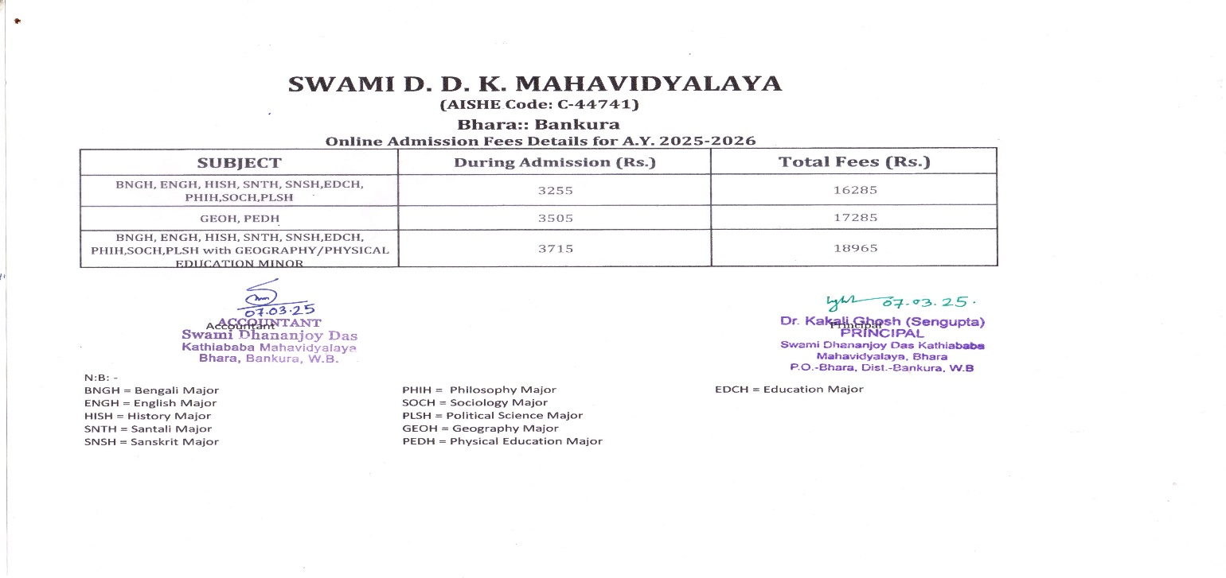

Sd/-
Dr. Kakali Ghosh Sengupta Principal
Siwami D.D. K. Mahavidvalava

College Garden in winter

COLLEGE RULES AND REGULATIONS

- Candidature will be cancelled if the candidate fails to meet registration and enrolment deadlines posted on the college website.
- Qualifying in Internal Exams is mandatory for exam registration and form fill up.
- Nostudentwillbeallowedtoenterthecollegepremiseswithoutthecollege ID Card.
- All fees that are due will have to be cleared within the stipulated date (follow college website).
- Meritorious students will be awarded the “Kathia baba Scholarship” on the basis of academic performance, attendance in class lecturesandincomecertificateverifiedbytheSDO/BDO/competentauthority.
- AllST, SC, OBC-A,OBC-B students are eligible for Govt. grant sand fellowships only if their attendance is above75percent.
- Ifastudentmisbehavesorisguiltyofunethicallbehaviourwithinthecollegepremiseslegalaction will be taken against him or her.
- Free ship will be awarded to selected needy and meritorious students.
- Under privileged and needy students who show a steady academic progress will receive aid from Student Aid Fund.
- Any kind of damage done to college property including library books, laboratory equipment, notice board and the college infrastructure in general may lead to strict punishment and even suspension.
- Admission procedure for first semester will be conducted solely through online procedure, adhering to the admission rules and regulations as specified under the NEP system of Bankura University.
- All information regarding admission rules and regulations will be available on the college website(www.bharacollege.in) and centralized admission portal
- Please read the rules carefully before filling up the admission form. The candidate will be responsible for any error committed while filling up the form and his/her admission may stand cancelled on account of wrong information provided with particular reference to H.S result.
- While filling up the Registration form please carefully insert the registered mobile number and mail-id. All information regarding USER ID PASSWORD and MERIT LIST will be communicated via SMS

ACADEMIC CALENDAR:
Students are advised to follow the college website [www.sddkm.in] and the college notice board regularly, for up-to-date information regarding class schedule, university registration, form fill up, study leave, exam schedule, and list of holidays.

VIRTUAL CLASSROOMS AND REMOTE TEACHING
As we are well aware post the Covid-crisis there has been a significant emphasis on virtual modes of teaching-learning, remote teaching and development of e-resources. Swami Dhananjoy Das Kathiababa College has done the needful in this respect upgrading its software and installing the ERP system to enable virtual learning. The college web page has a portal for e- resources, academic material and modular presentations which students can easily access. Faculty members use assistive apps such as Google classroom to distribute study matter and collect assignments. These virtual interactive forums have ensured a smooth transmission of knowledge in the absence of offline classroom teaching. In the post-Covid era the college intends to practice a blended mode of teaching balancing between online and offline modes of interaction.

COLLEGE LIBRARY

The College is equipped with a spacious library which has a sizeable collection of books and newspapers sand informative magazines and journals concerning career management. The library is managed by Librarian Smt Payel Shee and Library Assistant Shree Anup Kr Ghosh. Students avail of the resources in the library and spend time in the reading area for gathering information on various aspects of their study. The library apart from circulating academic material also houses magazines which provide information regarding various job vacancies. Apart from the Central library, Departmental library resources are also provided in case of some subjects. In future depart mental libraries will provide more specialized literature and study material on subjects specific topics.

LIBRARY RULES
Once admitted in the first semester, the student will be provided with a library card issued from the office. On producing this card the student will be permitted to borrow a maximum of three books from the library. Book issue and return facilities are operative on six days of the week. The borrowed books can be kept for a maximum of fifteen days. Failure to return the books on time will entail a fine calculated on a daily basis. Prior to form fill up for every semester it is mandatory to return all books borrowed. The college also provides internet access to students for accessing e- resources. At present the college has four desktops which can be accessed for reference work.

ADDITIONAL FEATURES DURING PANDEMIC TO FACILITATE
CIRCULATION OF RESOURCES
- Providing access to National Digital Library of India Platform(NDLI)

- International Webinar organized on “Role of College Libraries during Pandemic”

- E-Book Services

- Ask the Librarian: Students can communicate with the Librarian directly over WhatsApp, sending book requisitions as required

=========================== 00 ============================
•
•
•

NATIONAL SERVICE SCHEME

The College Magazine entitled Nabankur is published annually encouraging students and staff members to submit their essays, art work and creative writing which then undergo a screening process through the magazine committee. Wall magazines are also displayed by various departments showcasing student art works and writings. The 2024 edition of the magazine is available on the college website and very soon we will be publishing the 9th edition, dedicated to Manoj Mitra.

The College Annual Sports is a gala event where students can showcase their athleticism, sportsmanship and team spirit.
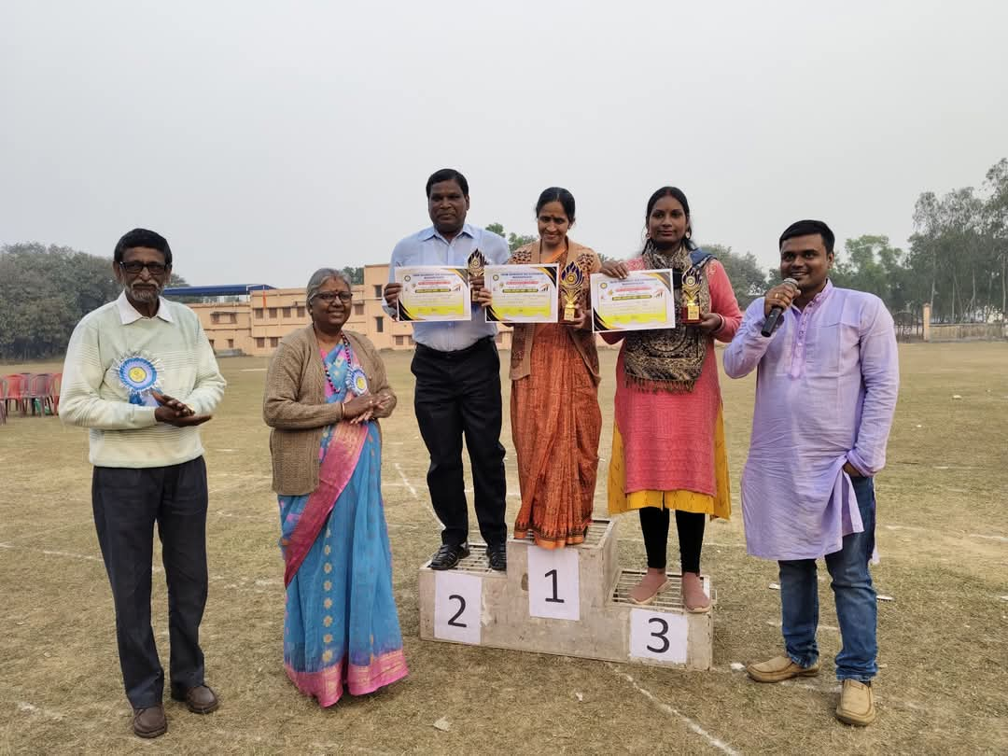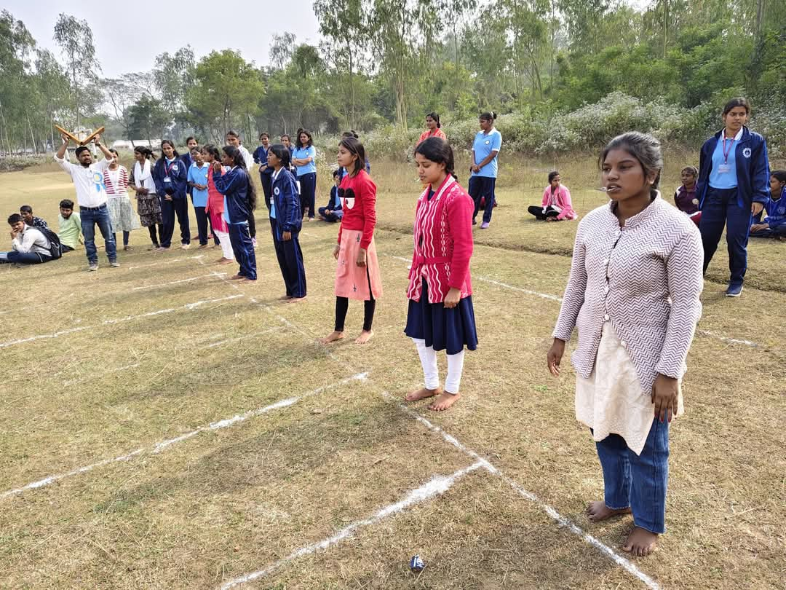

Snaps of College Annual Sports, 2024

DEPARTMENTAL HIGHLIGHTS

